SELECT * FROM OLA_DataSet

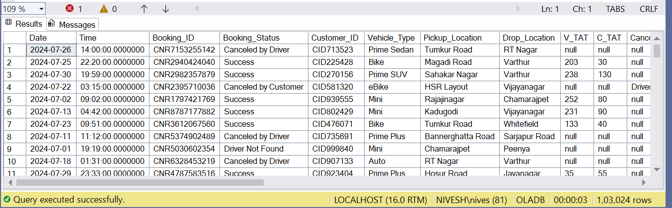

1. Retrieve all successful bookings:

SELECT *

FROM OLA_DataSet

WHERE Booking_Status = 'Success';

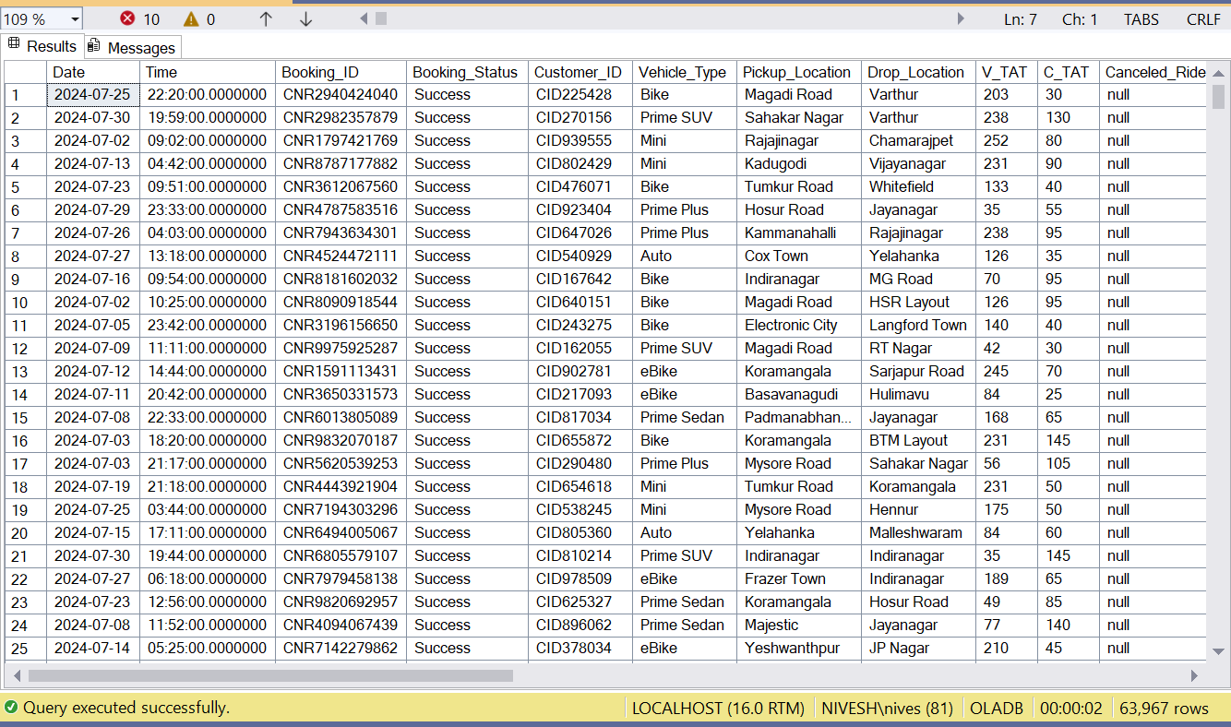

1. Find the average ride distance for each vehicle type:

SELECT

Vehicle_Type,

AVG(Ride_Distance) AS Avg_Ride_Distance

FROM

OLA_DataSet

GROUP BY

Vehicle_Type;

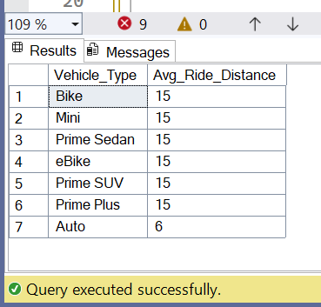

1. Get the total number of cancelled rides by customers:

SELECT

COUNT(Canceled_Rides_by_Customer)

FROM

OLA_DataSet;

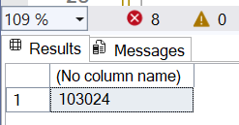

1. List the top 5 customers who booked the highest number of rides:

SELECT

Customer_ID,

COUNT(Booking_ID) AS total_rides

FROM

OLA_DataSet

GROUP BY

Customer_ID

ORDER BY

total_rides DESC

OFFSET 0 ROWS

FETCH NEXT 5 ROWS ONLY;

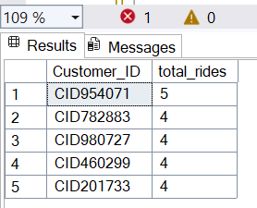

1. Get the number of rides cancelled by drivers due to personal and car-related issues:

SELECT COUNT(*) FROM OLA_DataSet

WHERE Canceled_Rides_by_Driver = 'Personal & Car related issue'

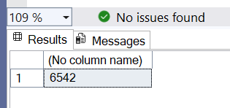

1. Find the maximum and minimum driver ratings for Prime Sedan bookings:

SELECT MAX(Driver_Ratings) AS max_rating,

MIN(Driver_Ratings) AS min_rating

FROM OLA_DataSet

WHERE Vehicle_Type = 'Prime Sedan';

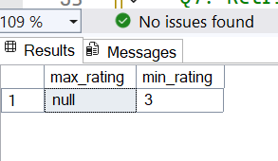

1. Retrieve all rides where payment was made using UPI:

SELECT * FROM OLA_DataSet

WHERE Payment_Method = 'UPI';

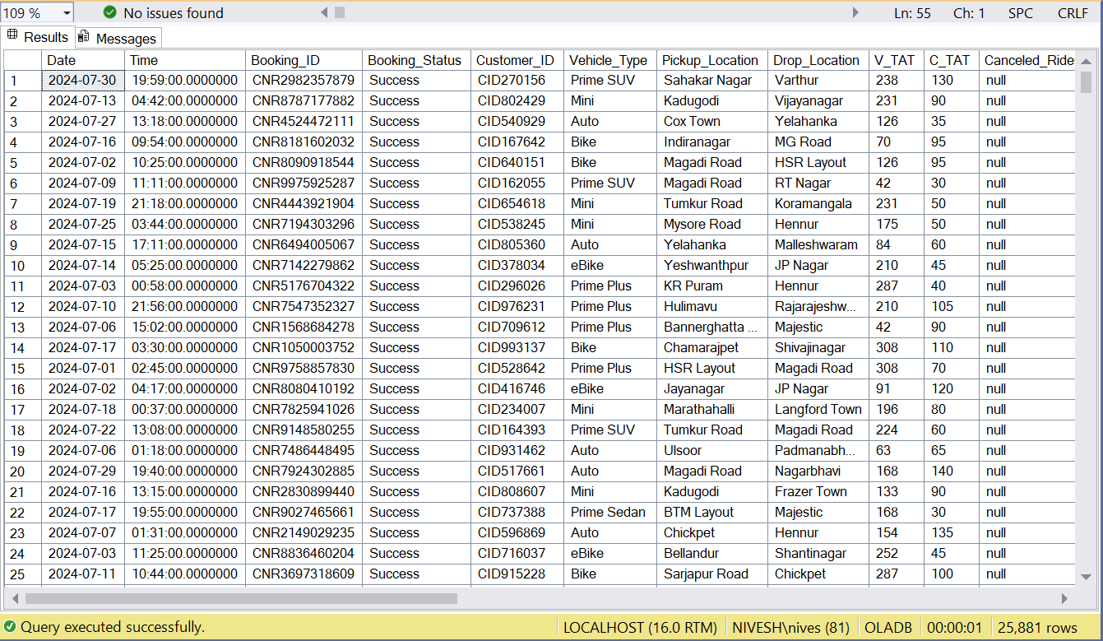

1. Find the average customer rating per vehicle type:

SELECT

Vehicle_Type,

CAST(AVG(TRY_CAST(Customer_Rating AS FLOAT)) AS DECIMAL(10,2)) AS avg_customer_rating

FROM

OLA_DataSet

GROUP BY

Vehicle_Type;

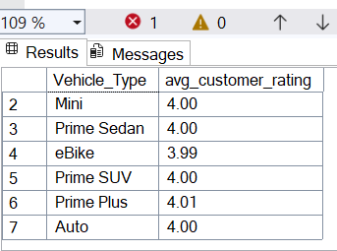

SELECT SUM(Booking_Value) AS Total_Successful_Value

FROM OLA_DataSet

WHERE Booking_Status = 'Success';

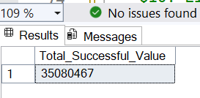

1. List all incomplete rides along with the reason

SELECT Booking_ID, Incomplete_Rides_Reason

FROM OLA_DataSet

WHERE Incomplete_Rides = 'Yes';

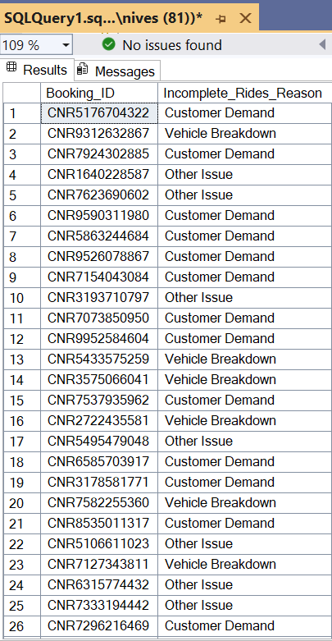

1. List all incomplete rides along with the reason
2. SELECT Booking_ID, Incomplete_Rides_Reason
3. FROM OLA_DataSet
4. WHERE Incomplete_Rides = 'Yes';

